1.When the doj Is not ready as per 180 days:

DOJ: 28-04-2026
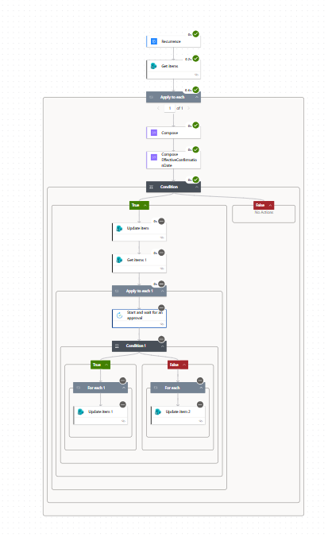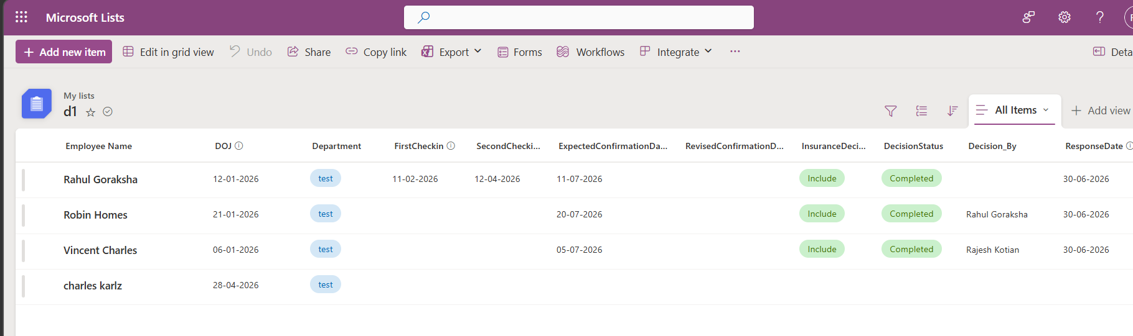

Remark: flow ran partially as: the doj of the Charles karlz was doj+180 days fulfilled

2.Now we will changes the doj to 12-02-2026 expected probabtion completion : 11-07-2026
In that scenario the flow will trigger the intimation to the supervisor who are been assigned to the respective department out of which : Approve/Reject : first to respond

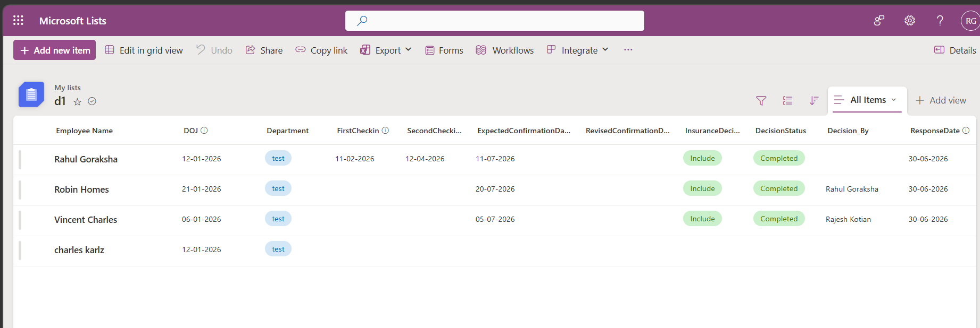

Flow started working
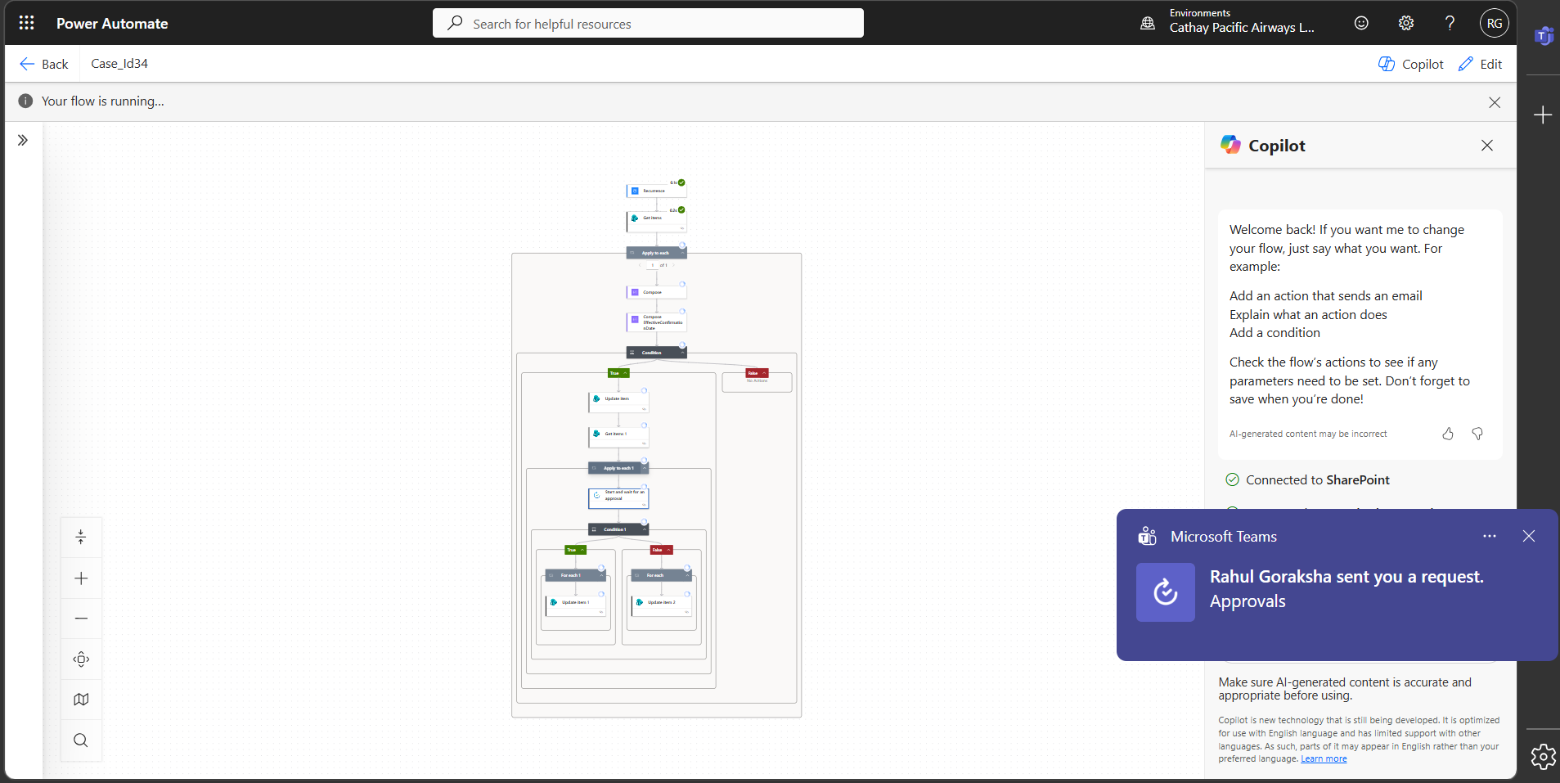
In Teams we can Notification saying weather Approve/Reject:
If we wanted to Reject then add the comment why you rejected an if approved then the comment which was mentioned during reject which will be wiped out after the decision_by changes its opinion to approved
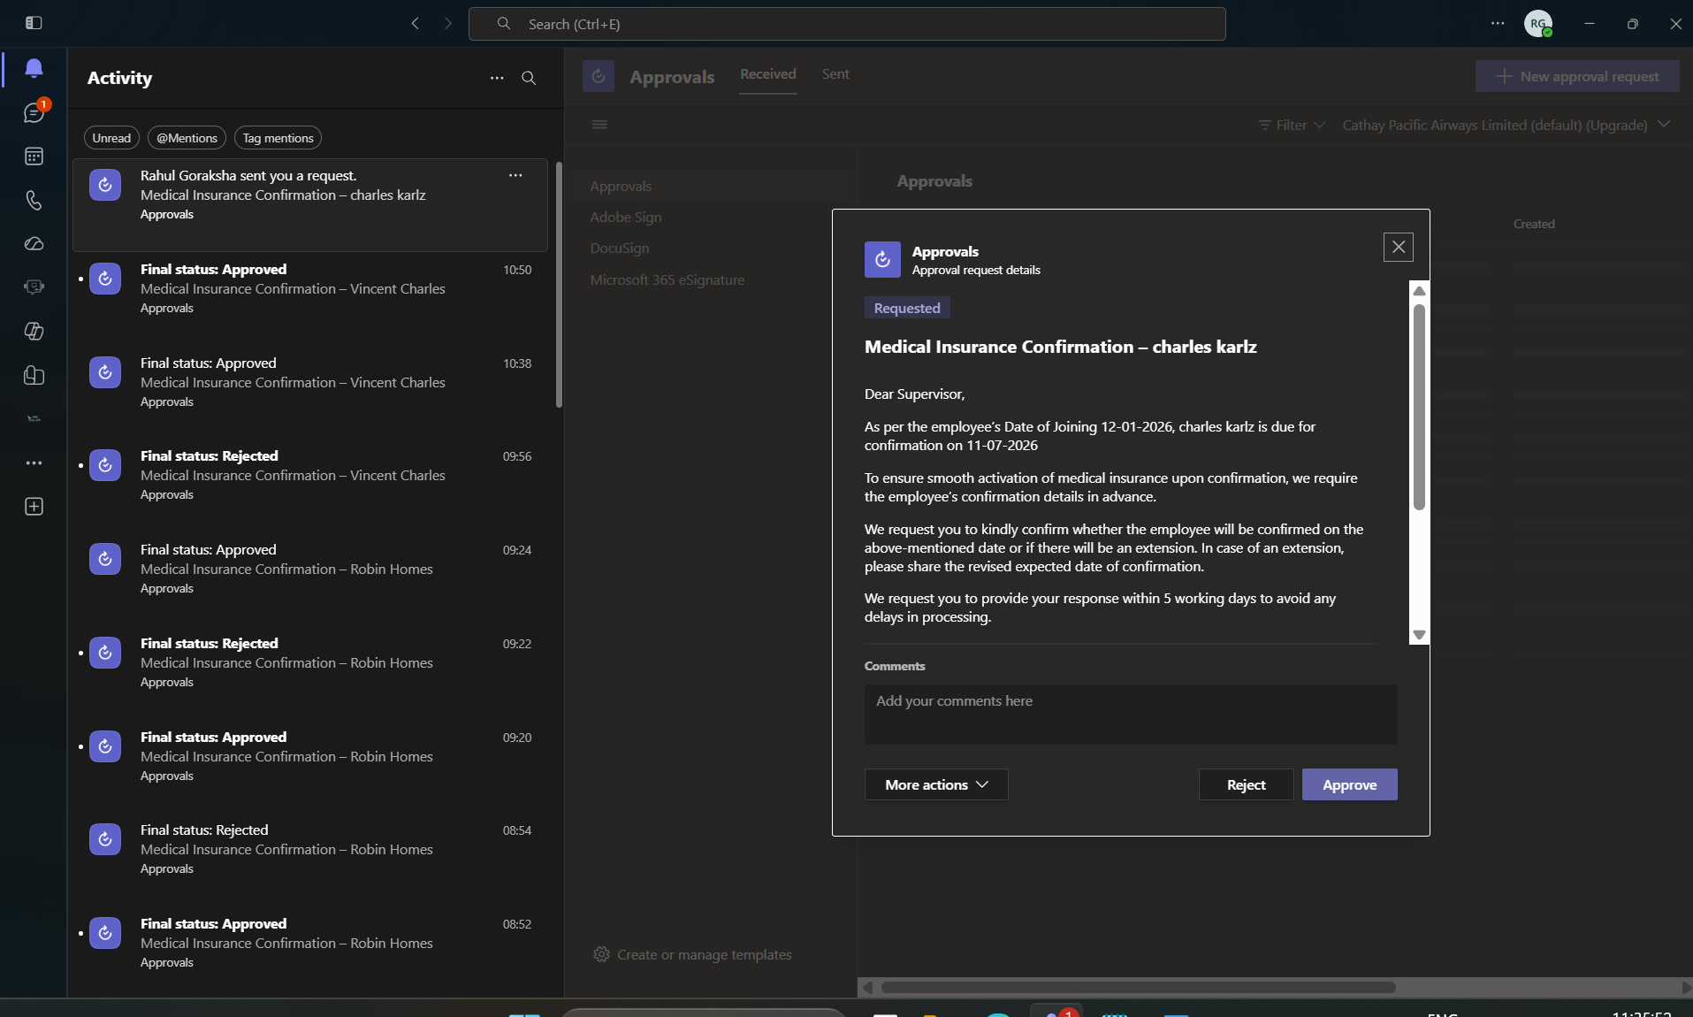

Rejected with additional comment beign mentioned in the comment box:
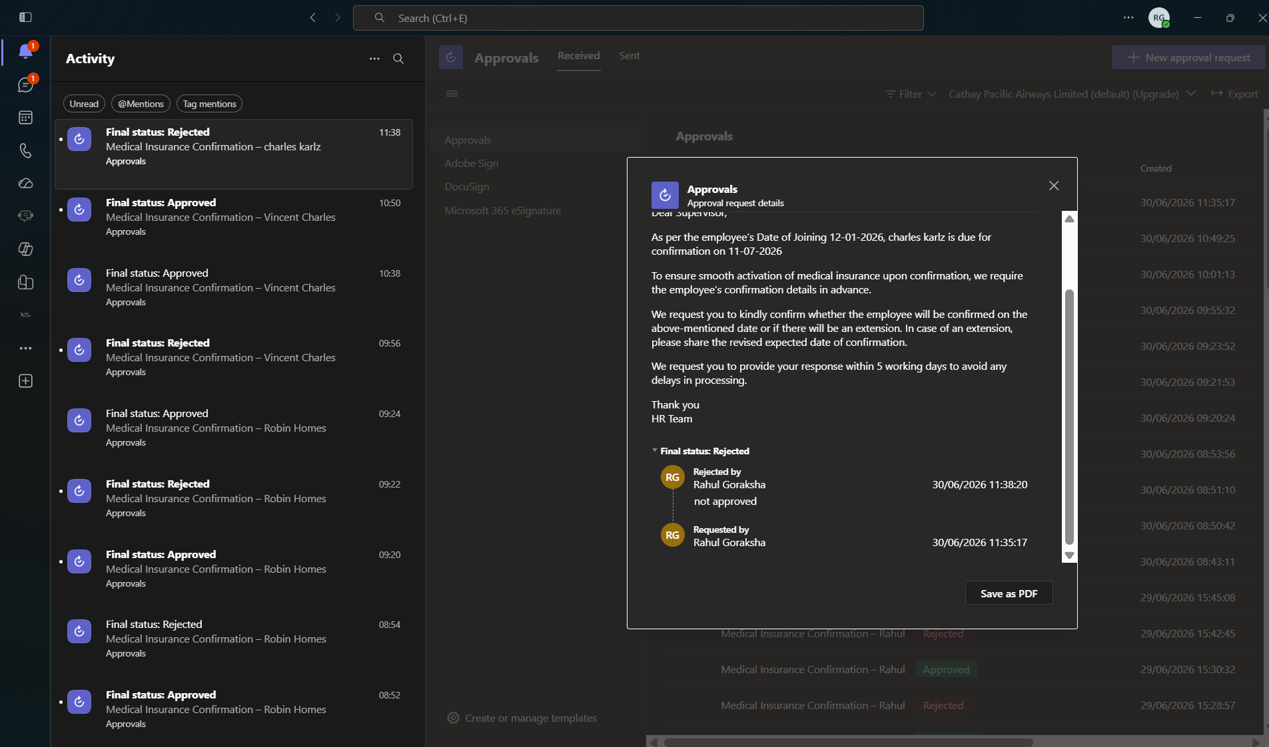
Because of this action it will reflect in the HR Trackment list as well
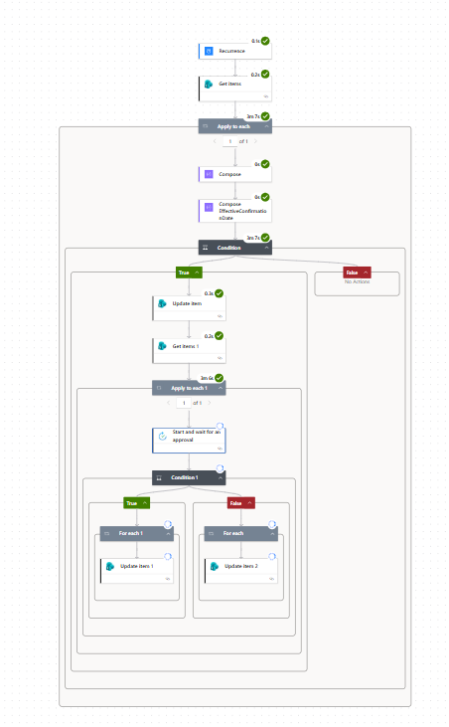
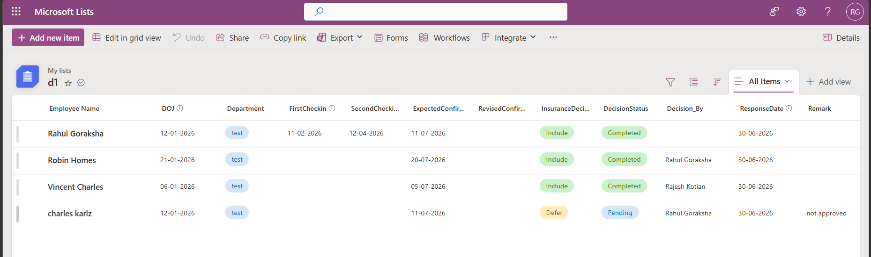

So now as I have defer and added comment it will once again notify in the upcoming month ok, also due to some reason if we have changed expected confirmation date 11-07-2026 an added manually revised confirmation date 11-09-2026 so in that case there automation will run from September onwards

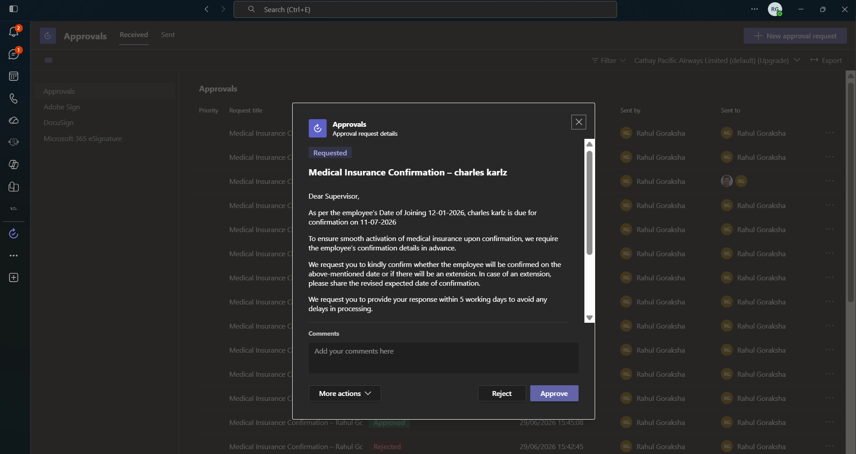
Now we will approve the request that we have received
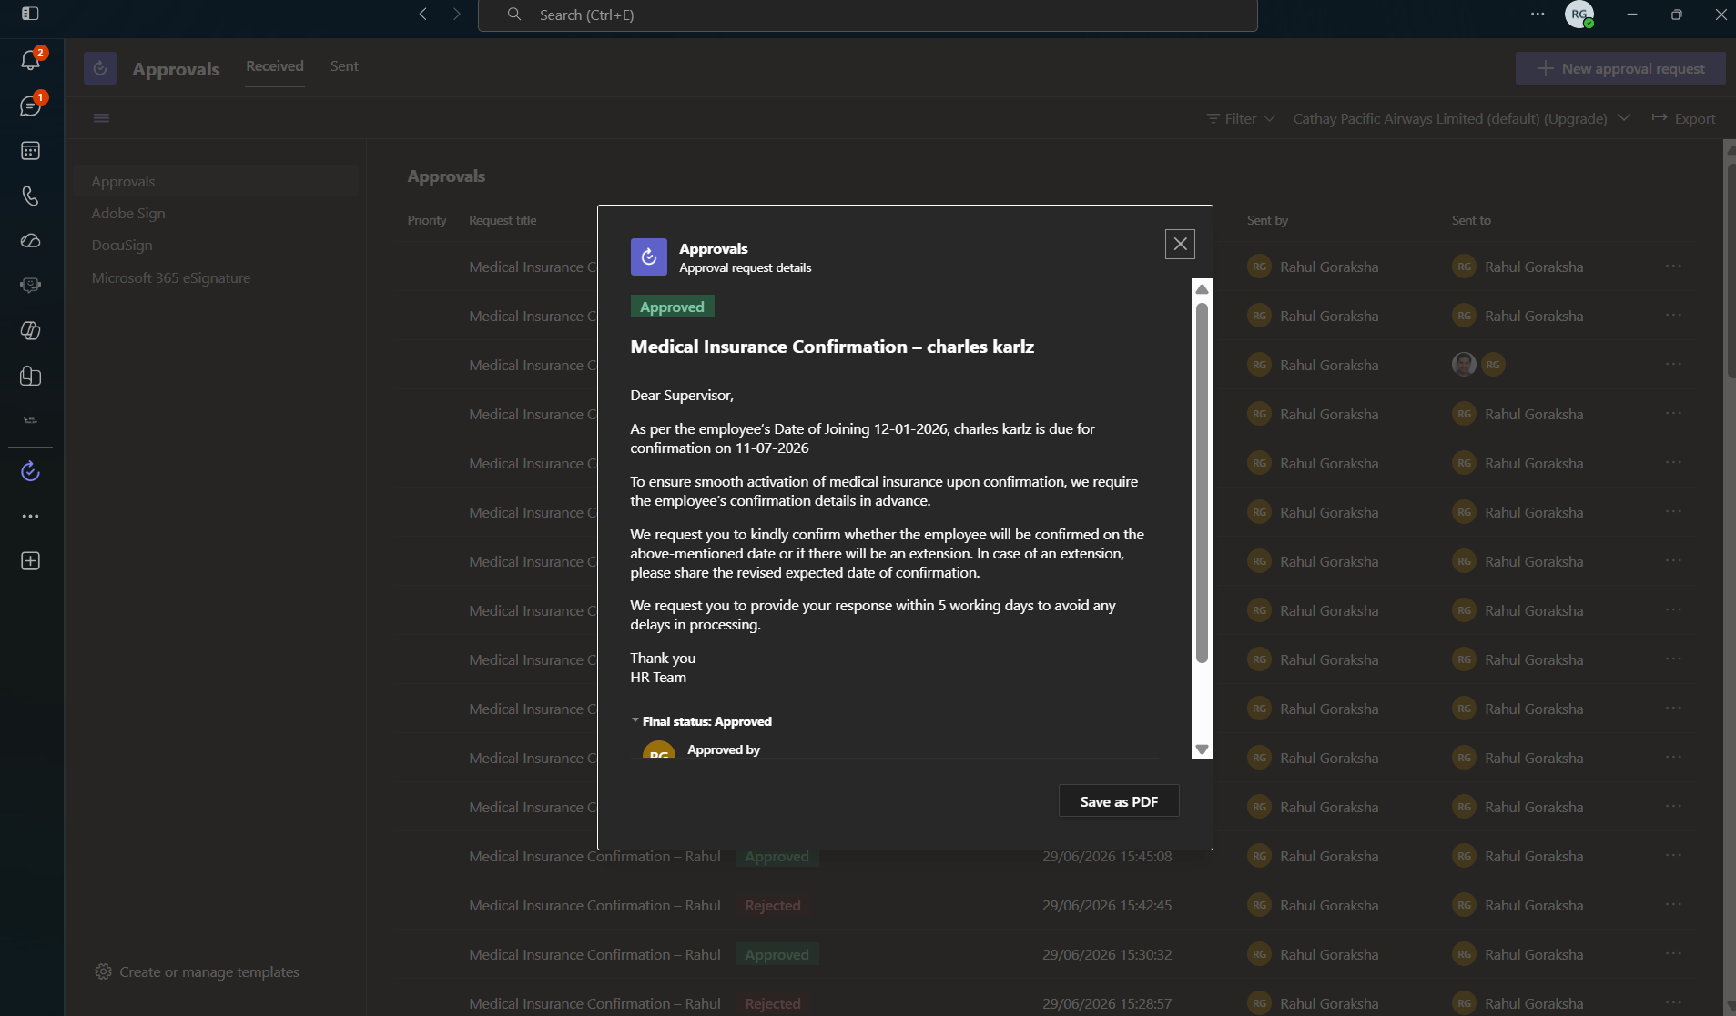
Also supervisor who first approve his response will get capture first along with when that supervisor response as well as along with the name of the responder as well as the supervisor can download the save as pdf and and share that summary with the HR Team as an token of an acknowledgement

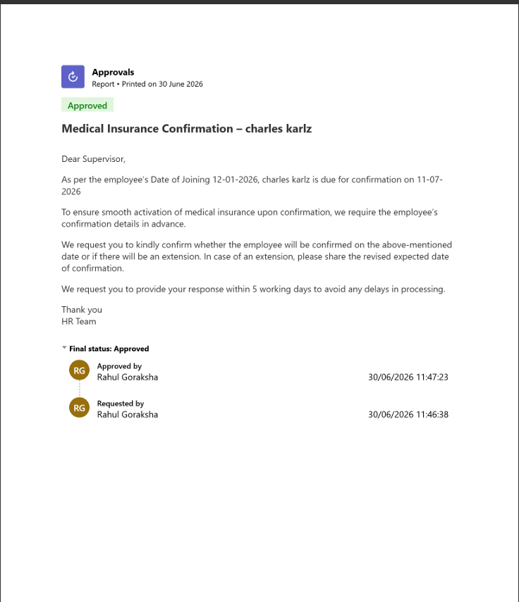
Now Hr will see the List Trackment where entire scenario of the approved so now as approved because of which it also clean the earlier remark which was added during the time of the rejection of the request

